How to use the QA/QC code:

Open the notebook: <https://colab.research.google.com/drive/1BUx3vC3Bm0Q8yJRg9zZ0vbYhdT8pyeq3#scrollTo=c6uxqU-0-g4A>

Click this icon to run import packages.

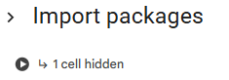

Import Data

You need to change the metType to whichever data table you are interested in.

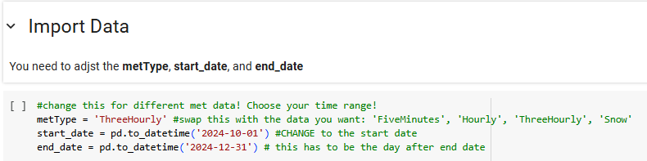You also need to adjust the time period in the start_date and end_date

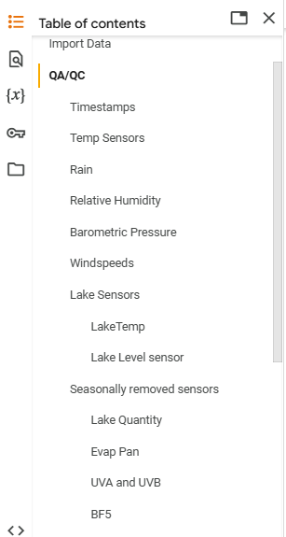In the table of contents under QA/QC open the seasonally removed sensors tab.

- each of these sensors (Lake Quantity, Evap Pan, etc) has a removal and installation date that is found on the [drive](https://docs.google.com/spreadsheets/d/148c4eCcSvezlGBthdnjp7JOMEvgKz8p4/edit?gid=578182220#gid=578182220)

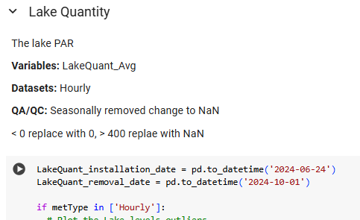-update each of these dates.

You will only need to adjust these dates with the first Met Table that you run (hourly, 5min, etc)

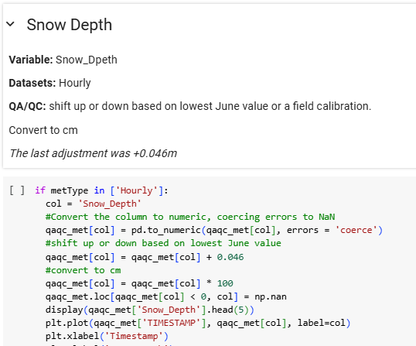

** Snow depth ** for the first snowfall.

Drop down to snow Depth tab at the bottom. Each fall with the first snow, we will adjust the snow depth to the lowest June value, or take a field measurement of the distance between the bottom of the sensor and the ground. This will be the offset value you will need to enter in the code.

* The file at the end should still be visually checked that it makes sense and if there was any summer snow fall, make sure that shows up correctly.
* This is only in Hourly

Now go back and collapse the QA/QC section so everything is bundled up.

Run the entire QA/QC section.

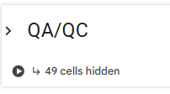

Expand each section clicking the sideways carrot (**>**) to check the graphs. If there is no graph output then just skip past it. The graphs are a visual clue for outliers that you can change in excel with the final product.

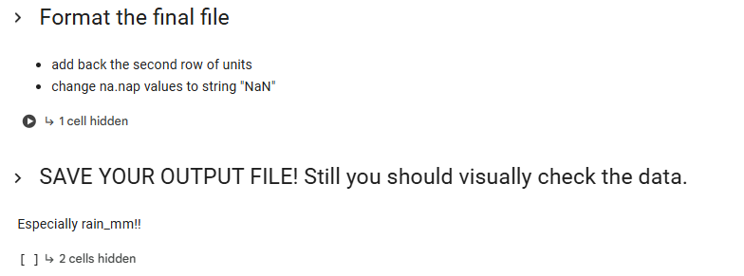Run the last two code blocks and your file will automatically download.

Do a manual check of Rain_mm_Tot to the naturalist journal to verify if it rain/snowed that day.

Now repeat most of this process for the other two data types.

For the other met data tables (5min, three hourly, etc) change the metType in the Import Data tab. Collapse QA/QC, run QA/QC block, check for graphs in each section, format and Save.

In the end, you will have three excel files that you can bring together.